פרויקט סיום בתכנות באייאט ומסאיי ☺
import datetime
def readAccounts():
accounts_list = []
account_file = open('accounts.csv', 'r')
for i in account_file:
split_acc = i[:-1].split(',')
tump_account = tuple(split_acc)
accounts_list.append(tump_account)
account_file.close()
return accounts_list
def readtransaction():
transaction_list = []
transaction_file = open('transaction.csv', 'r')
for i in transaction_file:
split_acc = i[:-1].split(',')
tump_transaction = tuple(split_acc)
transaction_list.append(tump_transaction)
transaction_file.close()
return transaction_list
def init():
account = readAccounts()
transaction = readtransaction()
return account,transaction
def saveAccounts(list):
file_acc = open('accounts.csv','w')
for tupel in list:
line = str(tupel[0])+',' + str(tupel[1]) + ',' + str(tupel[2])+'\n'
file_acc.write(line)
file_acc.close()
def saveTransactions(transaction_list):
file = open('transaction.csv', 'w')
for transaction_tupel in transaction_list:
line = transaction_tupel[0] + ',' + transaction_tupel[1] + ',' + transaction_tupel[2] + '\n'
file.write(line)
file.close()
def Save():
saveAccounts(readAccounts())
saveTransactions(readtransaction())
def menu():
user_choose = int(input("1.Create a new account\n2.Deposit to account\n3.Withdrawal Calculator\n4.Balance clarification\n5.Account transaction report\n6.exit\ntap your desired action:"))
if user_choose == 1:
add_account()
elif user_choose == 2:
deposit()
elif user_choose == 3:
withdraw()
elif user_choose == 4:
balance()
elif user_choose == 5:
report()
elif user_choose == 6:
return 6
def add_account():
account_number = input("enter your account number")
customer_name = input("enter your name ")
new_account = [account_number, ',0,', customer_name]
bool = True
account = readAccounts()
for i in account:
if account_number == i[0]:
bool = False
break
accounts = open('accounts.csv','a')
if bool:
accounts.writelines(new_account)
accounts.write('\n')
print('account been added to system')
elif bool == False:
print('account number exists, use another one')
accounts.close()
def deposit():
list_account = readAccounts()
number = input('enter number account: ')
deposit = float(input('enter amount of the deposit: '))
if func_account(list_account,number,deposit):
print('Update successful')
saveAccounts(list_account)
else:
print("Account not available")
def func_account(account_list,num,deposit):
DATE = datetime.datetime.now()
date = DATE.strftime('%d/%m/%Y %H:%M')
date = str(date)
for tup in account_list[1:]:
number_account,balance,full_name = tup
deposit = int(deposit)
balance = float (balance)
if number_account == num and deposit > 0:
sum_balance = balance + deposit
account_list.remove(tup)
account_list.append((num,sum_balance,full_name))
file_trans = open('transaction.csv', 'a')
file_trans.write(str(num))
file_trans.write(",")
file_trans.write(str(date))
file_trans.write(",")
file_trans.write(str(deposit))
file_trans.write("\n")
return True
return False
def withdraw():
account_list = readAccounts()
num = input('enter number account: ')
deposit = float(input('Enter withdrawal amount(negative number): '))
if updat_account_withdraw(account_list,num,deposit):
print('updat sccidet')
saveAccounts(account_list)
else:
print("the number account is not avanble or the withdrawal is not confirmed")
def updat_account_withdraw(accountlist,number,deposit):
x = datetime.datetime.now()
date = x.strftime('%d/%m/%Y %H:%M')
date = str(date)
for tupel in accountlist[1:]:
number_account,balace,full_name=tupel
deposit = int(deposit)
balace=float (balace)
if number_account==number and deposit < 0 :
deposit*-1
if balace >= deposit:
sum_balanc = balace + deposit
accountlist.remove(tupel)
accountlist.append((number,sum_balanc,full_name))
file = open('transaction.csv', 'a')
file.write(str(number))
file.write(",")
file.write(str(date))
file.write(",")
file.write(str(deposit))
file.write("\n")
return True
return False
def balance():
account_list = readAccounts()
number_account = input("enter your number account:")
bool = True
for i in account_list[1:]:
number, balance, full_name = i
if number == number_account:
print('your balance is :', balance)
bool = False
if bool:
print("The account number not exist")
def report():
Accounts_list = readAccounts()
transaction_list = readtransaction()
number_account=input("Enter your number account: ")
bool = False
for i in Accounts_list:
if number_account == i[0]:
bool = True
if bool:
print('Account:'.ljust(40),'Transactions:'.ljust(40))
for a in Accounts_list:
if number_account == a[0]:
print(a)
break
for b in transaction_list:
if number_account == b[0]:
print("".ljust(40), end="")
print(b)
else:
print('The account does not exist')
def main():
Accounts_list,transaction_list = init()
x = 0
while menu() != 6:
menu()
Save()
main()

1.יצירת חשבון חדש :
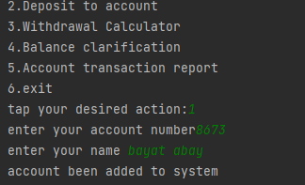

פלט החשבון החדש:
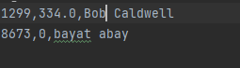

יצירת חשבון שכבר קיים:
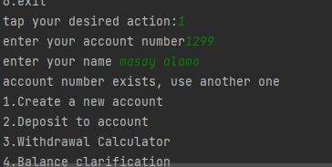
2. הפקדה לחשבון :
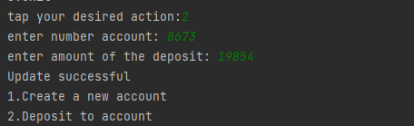

פלט הפקדה לחשבון :

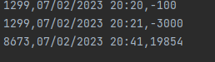

ניסיון להפקדה בחשבון לא קיים:

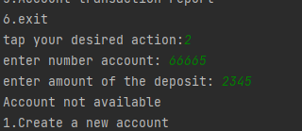

3.נסיון משיכה מחשבון לא קיים :

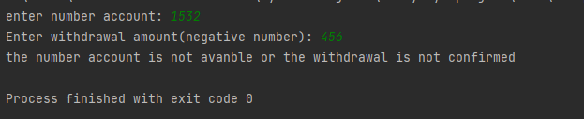

פלט של חשבון קיים לפני המשיכה:

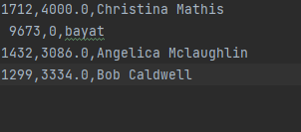

פעולה ביצוע משיכה :

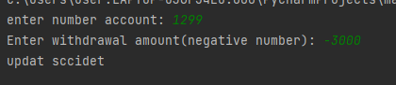

חשבון אחרי המשיכה:
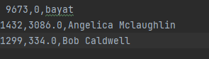

4. ניסיון לבירור יתרה לא קיים

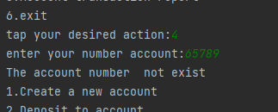

בדיקת בירור יתרה :
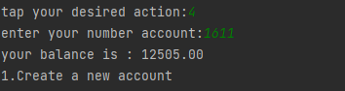

5.הפקת דוח פעולות תנועה(יש עוד לא הספיק הדף) :
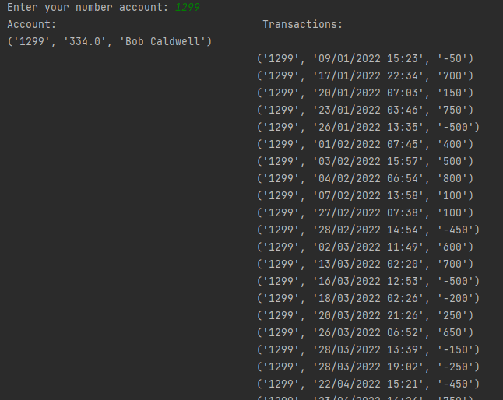

ניסיון להפקת דוח תנועות לחשבון לא קיים
